Systems Engineering Management Plan
(SEMP)

for the

Unmanned
Control & Tracking System
(UCATS)

Jennifer Greene
Kurt Chewning
Dave Manley
John Smith
Jeanette Smith

Sponsors: Dr. Kuo-Chu Chang
&
Ashwin Samant
Department of Systems Engineering & Operations Research
SYST 798 Applied Project Course
Fall 2009

FORWARD
This plan is applicable to the Unmanned Control & Tracking System (UCATS) to identify and define the organization(s), activities, overall tasks, principles, and objectives of Systems Engineering Management required to manage and control the project.

Beneficial comments (recommendations, additions, deletions) and any pertinent data which may be of use in improving this document should be sent to Jennifer Greene, Kurt Chewning, Dave Manley, John Smith, and/or Jeanette Smith by email.

This document corresponds to the UCATS Statement of Work (SOW) and used by both the acquirer and design authority for the identified project.

The primary objectives of this document are:
- To provide modern, state-of-the-art, project management requirements for the design, development, and evaluation of technical systems;
- To limit and reduce the proliferation of management documentation;
- Identify relevant directives and references;
- To provide evidence that control over the design, development, and evaluation;
- To provide emphasis on a disciplined integrated systems development approach;
- To acquaint newcomers with the concepts of systems engineering management and techniques.
- To provide visibility and communication of engineering management.

It is crucial that in design and development that questions should be asked and answers given; only in this way is it possible to integrate complex systems, to feedback information on past mistakes and successes and feed forward problems for which timely solutions must be found.

The scope and depth of the specific tasks chosen for application will be consistent with the needs of the UCATS. The need to correctly identify only the required tasks to suit the specific project cannot be overstated prior to contract negotiations. If any tasks are determined "not applicable" the paragraph will be identified as "not applicable".

TABLE OF CONTENTS

FORWARD 2
1.0 SCOPE 4
1.1 Identification 4
1.2 Purpose 4
1.3 Program Overview 4
1.4 Document Overview 6
1.5 Relationship to Other Standards and Plans 6
2.0 APPLICABLE DOCUMENTS 6
2.1 Order of Precedence 6
2.2 Source of Documents 7
3. TECHNICAL PROGRAM PLANNING & CONTROL 7
3.1 Stakeholders 7
3.2 Organization 8
3.3 Purpose and Activities 8
3.3.1 Responsibilities for design and development 8
3.4 Objectives 8
3.5 Development of Work Breakdown Structure (WBS) 8
3.6 Tasking 10
3.7 Program Risk Analysis 13
3.8 Formal Design Reviews 14
3.8.1 Systems Requirements Review (SRR) 14
3.8.2 Critical Design Review (CDR) 15
4.0 SYSTEMS ENGINEERING PROCESS 15
4.1 Mission Requirements Analysis 15
4.2 Architectural Analysis 16
4.3 Processes 16
APPENDICES 17
APPENDIX A: Acronyms 18

1.0 SCOPE

1.1 Identification
This System Engineering Management Plan (SEMP) establishes the overall plan for the System Engineering Management requirement for the Unmanned Control and Tracking System (UCATS).

1.2 Purpose
The purpose of this document is to identify and describe the overall organization, tasking, schedule, policies and processes for System Engineering Management (SEM) to be used during the UCATS development for George Mason University SYST 798 class. The SEMP shall be updated progressively as the work proceeds and the necessity arises. The primary intention of this SEMP is to provide information on the System Engineering Management policy and methods to be adopted and implemented for the project.

1.3 Program Overview
The UCATS tracks, coordinates, and directs airborne Unmanned Air Vehicles (UAVs) being used for mobile Target of Interest (TOI) tracking operations in an urban environment. The UCATS will reduce the manpower requirements encountered in the management of UAVs and the time required to generate a plan to have airborne UAVs intercept a TOI. Currently, the coordination and control of UAVs is a resource-intensive task in terms of manpower. The task of coordinating and controlling a single UAV requires several operators. The UCATS reduces the manpower resources by determining which in-flight UAVs are best capable to track TOIs, recommending a UAV intercept course, monitoring the position of the UAVs, and providing re-tasking if the operator needs to track a new TOI. Additionally, the time needed to generate intercept tasking is important when considering the TOIs are mobile, and the shorter the time to generate intercept tasking the better the prediction of where the TOIs may have gone, which increases the likelihood the UAVs will find the TOI to track. This collaborative control will increase efficiency, save money and resources, and aide in security and homeland defense.

UCATS consists of a ground based Command & Control (C2) center. The external systems that must interact with UCATS includes a manned by an operator and up to five airborne UAVs. UCATS will provide a decision support component to enable effective communication from the operator to the UAVs conducting the mission. The UCATS will be responsible for initiating and updating assignments to the UAVs in-flight based on the urban environment and TOI information given by a tasking authority. Figure 1 provides a notional view of the UCATS Concept of Operation (CONOPS).

Operationally, the UCATS recommends an intercept plan to the operator, communicate with UAVs, provide surveillance video from the UAVs to the operator, and accept operator’s requests and provide feedback. The intercept plan includes predicting the TOI location at UAV intercept, determining if the intercept is feasible, recommending a UAV intercept course, and recommends a UAV-to-TOI assignment. Initially, the UCATS operator will receive tasking to have one to five airborne UAVs track one to five TOIs. The operator will input intercept tasking requirements and set-up preferences, which include the TOI location and description, TOI priorities, and current local area maps, which include no-fly zones. Additionally, if the information is available, the operator can input the last known TOI heading and speed. The UCATS will then use those tasking requirements to generate an intercept plan. The operator will then use the UCATS recommendations to designate which UAV(s) should track which TOI(s). The UCATS will then communicate with the UAVs and direct the UAVs to follow the UCATS calculated route to the TOI. The UCATS will monitor the position of the UAVs. As the operators, receives new TOIs and tasking, they will then use the UCATS to re-evaluate the UAV tasking and then redirect the UAVs as needed.

The use of UCATS in conjunction with UAVs that can autonomously track TOIs has several potential uses. A system such as this could be used by the Department of Defense in the execution of the Global War On Terror (GWOT). Other agencies within the United States Government could have uses for this system such as: Border Patrol, Drug Enforcement Administration, Federal Bureau of Investigation, Homeland Security, and the Central Intelligence Agency.

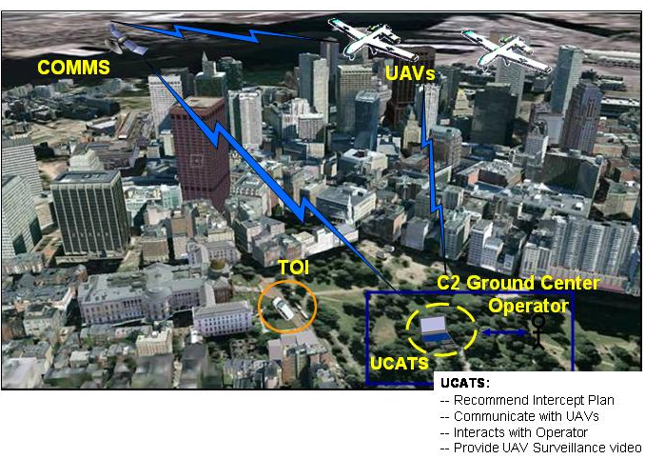
Figure 1.1 UCATS System

1.4 Document Overview
The following provides a summary of each section contained within this SEMP.
- Section 1 identifies, describes the purpose, introduces the objectives and summarizes the contents of the document;
- Section 2 lists the referenced documentation to which this document refers for further information;
- Section 3 outlines and describes the organizational structure and the technical program planning and control for performing the UCATS;
- Section 4 defines the System Engineering Process to be used for the specific project;
- Section 5 describes the integration and coordination of the program efforts for engineering specialty areas;
- Appendix A lists the abbreviations and acronyms used.

This document is based on the requirement for SEMP as identified in MIL-STD-499 and produced in accordance with the criteria identified therein.
The SEMP is living document and as a result additions, deletions, and modifications will occur as it is utilized. It will be updated as additional configuration activities are defined as the work proceeds and the necessity arises. Therefore, to provide configuration identification this standard will be identified with an issue or version number and released via configuration control to the relevant authorities.

1.5 Relationship to Other Standards and Plans
The SEMP is to be complimentary to and used in conjunction with the company policies and processes, development plans, system engineering processes, software development plans, configuration management plans, procedures, standards, and other processes and plans to meet the engineering management requirement for the UCATS.

2.0 APPLICABLE DOCUMENTS
Reference Documents
Statement of Work (SOW)
Product Assurance Plan (PAP)
Risk Management Plan (RMP)
System Requirements Specification (SRS)
UCATS CONOPS

2.1 Order of Precedence
In the event of a conflict between this document and the references cited herein, the text of this document takes precedence. Nothing in this document, however, supersedes applicable laws and regulations unless a specific exemption has been obtained; in which case the exemption will be identified in the text. In the event of a conflict between this document and the contract, the text in the contract will take precedence. When detailed specifications are required to meet an operational requirement, a waiver will be obtained for their use.

2.2 Source of Documents
UCATS program plan documents will be available from the project library maintained on the web based Integrated Development Environment (IDE) located at http://mason.gmu.edu/~jgreene7 .

3. TECHNICAL PROGRAM PLANNING & CONTROL
This portion of the plan will identify organizational responsibilities and authority for SEM, including levels of control established for performance and a design, requirements and the control method to be used, technical program assurance methods, plans and schedules for design and technical program reviews, and control of documentation.

3.1 Stakeholders
The UCATS program is organized to support multiple program goals and objectives and to support a diverse set of stakeholders. Figure 3.1.1-1 identifies the stakeholders.
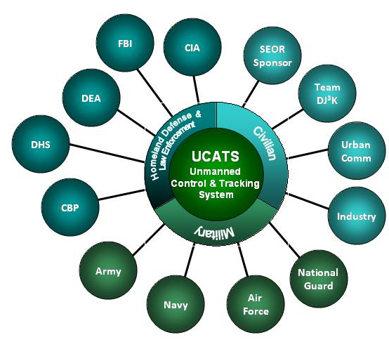
Figure 3.1-1 UCATS Stakeholders

3.2 Organization
The Naval Surface Warfare Center Dahlgren Division (NSWCDD) SYST-798 Team DJ3K team will use the organization shown in Figure 1 to develop the system architecture for the UCATS. The NSWCDD SYST-798 Team DJ3K team consists of the following members:
- Kurt Chewning
- Jennifer Greene
- Dave Manley
- Jeanette Smith
- John Smith
Program Manager
Dave Manley
Systems Engineer
Jennifer Greene
Functional Architect Lead
Jeanette Smith
Systems Problem Lead
John Smith

Instantiated Architect Lead
Kurt Chewning
Figure 3.2-1 UCATS Organizational Chart

3.3 Purpose and Activities
The purpose of the SEMP is to establish, identify, and define tasks required to progress the operational need from concept to the deployment of the specific system.

3.3.1 Responsibilities for design and development
The different system engineering leads will be responsible for the preparation and maintenance of the specific design data.

3.4 Objectives
The SEMP will be applicable throughout the design stages and phases of the system. The SEMP will establish and document the process by which the system is managed from concept to design.

3.5 Development of Work Breakdown Structure (WBS)
The technical elements of the WBS/SOW will be developed initially and refined as the project progresses. The latest revision of the WBS is shown in Table 3.2-1.
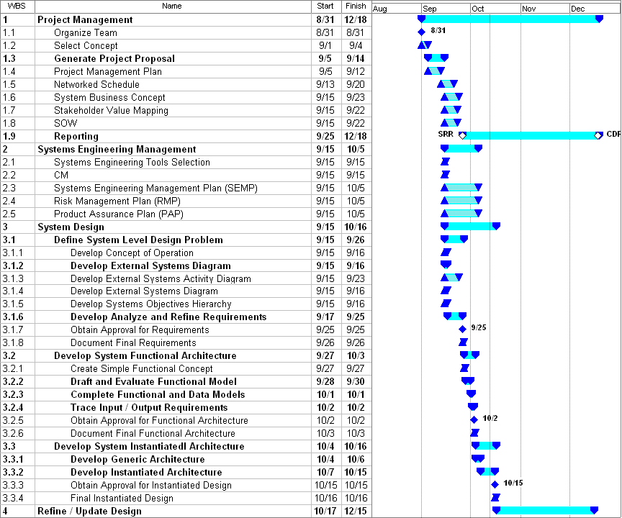
Table 3.2-1 UCATS WBS

3.6 Tasking
Table 3.6-1 summarizes the UCATS tasking, due date, the Team DJ3K member (Point of Contact (POC)) responsible for coordinating the development of the deliverable, and whether this is a formal project deliverable of a systems engineering product used to develop the system. This POC is not necessarily responsible for generating the entire deliverable, but instead will collect and consolidate all the deliverables from the team.

WBS |  | Dates |  | POCs
# | Name | Start | Finish | Chewning, Kurt | Greene, Jennifer | Manley, Dave | Smith, Jeanette | Smith, John
1. | Project Management | 31-Aug | 18-Dec |  |  | Lead
1.1 | Organize Team | 31-Aug | 31-Aug | All | All | All | All | All
1.2 | Select Concept | 1-Sep | 4-Sep | All | All | All | All | All
1.3 | Generate Project Proposal | 5-Sep | 14-Sep |  |  |  | Lead
1.3.1 | Project Proposal Presentation | 4-Sep | 13-Sep | SME
1.3.2 | Project Proposal Summary | 4-Sep | 13-Sep |  |  |  |  | SME
1.3.3 | Proposal Scoped and Approved | 14-Sep | 14-Sep | All | All | All | All | All
1.4 | Project Management Plan | 5-Sep | 12-Sep |  |  | SME
1.5 | Networked Schedule | 13-Sep | 20-Sep |  |  | SME
1.6 | System Business Concept | 15-Sep | 23-Sep |  |  | SME
1.7 | Stakeholder Value Mapping | 15-Sep | 23-Sep |  | SME
1.8 | SOW | 15-Sep | 23-Sep |  |  |  | SME
1.9 | Reporting | 17-Oct | 18-Dec |  |  |  | Lead
1.9.1 | Final Presentation | 17-Oct | 18-Dec | SME
1.9.1.1 | Rough Draft Presentation | 17-Oct | 13-Nov | SME
1.9.1.2 | Final Draft Presentation | 14-Nov | 18-Dec | SME
1.9.2 | Final Report | 17-Oct | 18-Dec |  | SME
1.9.2.1 | Rough Draft Report | 17-Oct | 13-Nov |  | SME
1.9.2.2 | Final Draft Report | 14-Nov | 18-Dec |  | SME
2.0 | Systems Engineering Management | 15-Sep | 18-Dec |  | Lead
2.1 | Systems Engineering Tools Selection | 15-Sep | 15-Sep | All | All | All | All | All
2.2 | CM | 15-Sep | 18-Dec |  | SME
2.3 | Systems Engineering Management Plan (SEMP) | 15-Sep | 5-Oct |  | SME
2.4 | Risk Management Plan (RMP) | 15-Sep | 5-Oct |  | SME
2.5 | Product Assurance Plan (PAP) | 15-Sep | 5-Oct |  | SME
3.0 | System Design | 15-Sep | 16-Oct | All | All | All | All | All
3.1 | Define System Level Problem | 15-Sep | 26-Sep |  |  |  |  | Lead
3.1.1 | Develop Concept of Operations | 15-Sep | 16-Sep |  | SME
3.1.2 | Develop Use Cases | 15-Sep | 23-Sep |  |  | SME
3.1.3 | Develop External Systems Activity Diagram | 15-Sep | 23-Sep |  |  | SME
3.1.4 | Develop External Systems Diagram | 15-Sep | 16-Sep |  |  |  |  | SME
3.1.5 | Develop Systems Objectives Hierarchy | 15-Sep | 16-Sep |  |  | SME
3.1.6 | Develop Analyze and Refine Requirements | 17-Sep | 25-Sep |  |  |  | SME | SME
3.1.7 | Obtain Approval for Requirements | 25-Sep | 25-Sep | All | All | All | All | All
3.1.8 | Document Final Requirements | 26-Sep | 26-Sep |  |  |  |  | SME
3.2 | Develop System Functional Architecture | 27-Sep | 3-Oct |  |  |  | Lead
3.2.1 | Create Simple Functional Concept | 27-Sep | 27-Sep |  |  | SME
3.2.2 | Draft and Evaluate Functional Model | 28-Sep | 30-Sep |  |  | SME
3.2.2.1 | Conduct Functional decomposition Brainstorming | 28-Sep | 28-Sep | All | All | All | All | All
3.2.2.2 | Conduct Functional Decomposition Trade Study | 29-Sep | 29-Sep |  |  | SME
3.2.2.3 | Select Functional Decomposition | 30-Sep | 30-Sep | All | All | All | All | All
3.2.3 | Complete Functional and Data Models | 1-Oct | 1-Oct |  | SME
3.2.3.1 | Generate Initial Functional Models | 1-Oct | 1-Oct |  | SME
3.2.3.2 | Generate System Activity Diagrams | 1-Oct | 1-Oct |  |  | SME
3.2.3.3 | Identify / Draft Sub-System Interface Requirements | 1-Oct | 1-Oct |  | SME | SME
3.2.4 | Trace Input / Output Requirements | 2-Oct | 2-Oct |  | SME
3.2.4.1 | Complete Draft IDEF A0 & A1 Diagrams | 2-Oct | 2-Oct |  | SME
3.2.4.2 | Complete Draft IDEF A2 Diagrams | 2-Oct | 2-Oct |  |  | SME | SME | SME
3.2.5 | Obtain Approval for Functional Architecture | 3-Oct | 3-Oct | All | All | All | All | All
3.2.6 | Document Final Functional Architecture | 3-Oct | 3-Oct |  | SME | SME | SME | SME
3.3 | Develop System Instantiated Architecture | 4-Oct | 16-Oct | Lead
3.3.1 | Develop Generic Architecture | 4-Oct | 6-Oct | All | All | All | All | All
3.3.1.1 | Brainstorm Architecture | 4-Oct | 4-Oct | All | All | All | All | All
3.3.1.2 | Generate Trade-Offs | 5-Oct | 5-Oct | SME | SME | SME | SME | SME
3.3.1.3 | Down-Select Generic Architecture | 6-Oct | 6-Oct | All | All | All | All | All
3.3.2 | Develop Instantiated Architecture | 7-Oct | 15-Oct | All | All | All | All | All
3.3.2.1 | Brainstorm Instantiated Architecture Components | 7-Oct | 7-Oct | All | All | All | All | All
3.3.2.2 | Generate Morphological Box - Instantiated Sys Arch Sub-Sys | 8-Oct | 9-Oct | SME | SME | SME | SME | SME
3.3.2.3 | Conduct Sub-System Trade-Off Analysis | 10-Oct | 12-Oct | SME | SME | SME | SME | SME
3.3.2.4 | Down Select Instantiated Architecture | 13-Oct | 13-Oct | All | All | All | All | All
3.3.2.5 | Finalize Sub-System Interface Requirements | 14-Oct | 14-Oct | SME | SME | SME | SME | SME
3.3.2.6 | Document Instantiated Draft Design | 15-Oct | 15-Oct | SME | SME | SME | SME | SME
3.3.3 | Obtain Approval for Instantiated Architecture | 15-Oct | 15-Oct | All | All | All | All | All
3.3.4 | Final Instantiated Design | 16-Oct | 16-Oct | All | All | All | All | All
4.0 | Refine / Update Design | 17-Oct | 15-Dec | All | All | All | All | All
4.1 | System Requirements | 17-Oct | 15-Dec |  |  |  |  | Lead
4.2 | Functional Design | 17-Oct | 15-Dec |  |  |  | Lead
4.3 | Instantiated Design | 17-Oct | 15-Dec | Lead
Legend:
All team memebers participate in this task
Lead: Responsible for leading a major project effort
SME: Responsible for conducting a specific task
Table 3.6-1 Task List

3.7 Program Risk Analysis
The program definition and re-definition effort shall include a continuing analysis of the risks associated with the related cost, schedule, and technical parameters.

Managing risk is an internal part of the UCATS program to insure all of the associated work products meet the operational needs in a timely, cost effective manner. The managing of risk begins with an understanding of the program risks. The UCATS approach is documented in the Risk Management Plan and describes the methodology for gathering, maintaining, adjudications and tracking all risks and opportunities for the UCATS program (including all constituent programs).

To elicit program risks, the following sources will be monitored:
- Requirements. The sensitivity of the program to uncertainty in the system description and requirements. Requirements include operational needs, attributes, performance parameters, constraints, technology, design processes, and WBS elements.
- Technology. The degree to which the technology proposed for the program has demonstrated sufficient maturity to be realistically capable of meeting all of the program’s objectives.
- Logistics. The ability of the system configuration and associated documentation to achieve the program’s logistics objectives based on the system design, maintenance concept, support system design, and availability of support data and resources.
- Management. The degree to which program plans and strategies exist and are realistic and consistent.
- Schedule. The adequacy of the time allocated for performing the defined acquisition tasks.

Additional areas, such as manpower, and systems engineering, will be analyzed during the project for indicators of additional risk.

After the program risks have been formally approved in accordance with the RMP; the necessary mitigation activities will be developed. These mitigation activities will include the necessary tasking, schedule, and decision points to insure the success of the program execution. All mitigation activities will require formal approval in accordance with the RMP. With approval, the mitigation activities will be integrated into the program schedule and work packages if necessary. The mitigation activities will be tracked as part of the normal program management activity and will be statused during the Risk Management meeting as described in the RMP.

3.8 Formal Design Reviews
The UCATS program plan is designed to invoke system engineering process on the analysis and definition of requirements, and the development and integration of design solutions.

3.8.1 Systems Requirements Review (SRR)
An SRR is scheduled to examine the system functional and performance requirements. The objectives include but not limited to:
1. Ascertain the adequacy of the defined system requirements, i.e., that system requirements are understood, complete, and verifiable;
2. Evaluate the traceability and technical risks associated with the preliminary requirement allocations; and
3. Review plans, milestone schedules, and trade study results.
The entrance criteria and exit criteria for the SRR are defined in Table 3.8.1-1 and Table 3.8.1-2.

Tailored Entrance Criteria | Product
A Draft System Requirements Specification (SRS) has been developed and has been made available for review, | Draft SRS
A Draft UCATS Concept of Operations has been developed and has been made available for review. | CONOPs
Total system approach to satisfying requirements has been developed as draft management plans, and has been made available for review. | SEMP
A risk management approach is developed and deemed satisfactory. Risks have been identified and a plan to put finalize mitigation plans for each risk has been identified. | RMP
Table 3.8.1-1 Tailored Entrance Criteria SRR

Tailored Exit Criteria | Product
A draft System Engineering Management Plan (SEMP) has been developed, reviewed, all comments have been adjudicated, and any resulting action items are assigned with appropriate resources identified. | SEMP
A Draft Risk Management Plan (RMP) has been developed, reviewed, all comments have been adjudicated, and any resulting action items are assigned with appropriate resources identified. | RMP
Project sponsor concurs with updated SRS | Approved SRS
The UCATS review team will provide a statement of findings and recommendations to the executive panel during CDR. | UCATS Review Team Report Out
Table 3.8.1-2 Tailored Exit Criteria SRR

3.8.2 Critical Design Review (CDR)
System CDRs are scheduled to examine detail design and to determine if the design is complete and ready for the next stage in development. CDRs will be held in front of the executive panel, which consists of Dr. Speller, K.C. Chang, and/or the SEOR Faculty.

The entrance criteria and exit criteria for the CDR are defined in Table 3.8.4-1 and Table 3.8.4-2.

Tailored Entrance Criteria | Product
SRR Action Items have been closed or sufficient progress has been made. | Updated SRS
Instantiated UCATS Design | External Systems Diagram  IDEF UCATS Functional Diagrams  Instantiated Design
Documentation complete for detailed design and processes. | UCATS Report  UCATS Presentation
Table 3.8.2-1 Tailored Entrance Criteria CDR

Tailored Exit Criteria | Product
Program implementation schedule approved and complete | Updated UCATS Report  Updated UCATS Presentation
Table 3.8.2-2 Tailored Exit Criteria CDR

4.0 SYSTEMS ENGINEERING PROCESS
The plan shall contain a detailed description of the process to be used, including the specific tailoring of the process to the requirements of the system and project; the procedures to be used in implementing the process; and in-house documentation.

4.1 Mission Requirements Analysis
Impacts of the stated system operational characteristics, mission objectives, and minimum acceptable system functional requirements will be analyzed during the course of the project.

The purpose of the Mission Requirements Analysis step is to support the system design by examining design tradeoffs and sensitivity of the design of UCATS. Mission Requirements Analysis consists of analyzing the system, developing the operating concept, analyzing requirements, and supporting other technical and management tasks. These tasks are captured under WBS element 3.1 – Define System Level Problem.

4.2 Architectural Analysis
System capabilities will be identified and analyzed as the basis for identifying alternatives for meeting system performance and design requirements. The UCATS architecture design process defines the logical grouping of domain related functionality as a set of domain related subsystems within the system. The system architecture design process includes the analyses, trade studies, and modeling/simulation activities required to determine design constraints. In execution of the system design activity, UCATS will employ a model-based systems engineering process with the goal of defining a set of complementary IDEF0 models. These tasks are captured under WBS element 3.2 – Develop System Functional Architecture and WBS element 3.3 – Develop System Instantiated Architecture.

4.3 Processes
NSWCDD Team DJ3K will develop the Collaborative UAV System Design by assigning one person to coordinate the development of a specific task or deliverable (See Table 3.6-1). This POC will not necessarily be responsible for developing the item, but they will be responsible for coordinating and consolidating all inputs. Team DJ3K will ensure the quality of the deliverable by using a peer review process. After the POC has developed a final draft of the task or deliverable, they will email it to the team for a peer review. The POC will be responsible for setting a peer review due date for inputs and coordinating the update of the deliverable and resolution of all team comments.

APPENDICES

APPENDIX A: Acronyms

CDR Critical Design Review
CM Configuration Management
CONOPs Concept of Operations
IDE Integrated Development Environment
PAP Product Assurance Plan
RMP Risk Management Plan
SEM Systems Engineering Management
SEMP Systems Engineering Management Plan
SOW Statement of Work
SRR System Requirements Review
SRS System Requirements Specification
TOI Target of Interest
WBS Work Breakdown Structure
UCATS Unmanned Control & Tracking System

